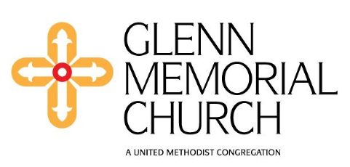
Tice

An update from the Draw the Circle Wide task force regarding General Conference
The General Conference is the only body that has the authority to speak on behalf of The United Methodist Church, which is a global church. The General Conference is the only body that can amend the Book of Discipline. Due to COVID and the related pandemic, the General Conference of The United Methodist Church has not convened since its February 2019, Special Session. General Conference is scheduled to meet again in Charlotte, North Carolina in 2024. Information about this upcoming meeting can be found here: United Methodists to Meet in Charlotte for Worldwide Conference (umc.org)
Much of the language in the Book of Discipline regarding human sexuality has been in place since 1972, despite numerous proposals to make it less restrictive regarding the ordination of gay and lesbian persons and the ability of United Methodist clergy to officiate at the weddings of gays and lesbians. Glenn Memorial United Methodist Church, along with hundreds of other congregations, continues to seek changes in this regard. In 2011, Glenn started the Rainbow Advocacy Group (now Draw the Circle Wide) to discern Glenn’s continuing role in affirming LGBTQIA+ rights and rites in the church. In 2014, Glenn joined the Reconciling Ministries Network and, in 2015, Glenn was awarded the Emory University Office of LGBTQIA+ Life’s Outstanding Ally of the Year Award and recognized for its creation of an inclusive, respectful and safe climate for the Emory LGBTQIA+ community. You can read more about this important work here. More about this important work online here.
During this prolonged season between meetings of the General Conference there are congregations that are choosing to disaffiliate from The United Methodist Church in order become independent or to join other denominations or to join the more conservative/traditional new denomination called the Global Methodist Church. Each United Methodist Annual Conference has the authority to guide the process for disaffiliation.

In December, Bishop Sue Haupert-Johnson and her Cabinet, announced a pause in the disaffiliation process in the North Georgia Conference. More about this pause (including a helpful Q&A section) can be found online at NGUMC | North Georgia Conference to Pause Disaffiliation Process
Other bishops have issued similar directives or have written pastoral letters, such as the one written by Bishop David Graves of the South Georgia and Alabama West Florida Conferences addressing the disaffiliation process . Bishop Graves’ pastoral letter can be found here: AWFUMC: A Word from Bishop Graves: This is NOT a business deal

What’s next?
Glenn Memorial United Methodist Church will continue to make disciples of Jesus Christ for the transformation of the world. This transformational work and ministry will continue to be expressed in a number of ways, including through the church’s clear commitment to welcoming, affirming, and supporting members of our LGBTQIA+ family.
Glenn is not seeking to disaffiliate from The United Methodist Church; rather the church is continuing to advocate for the removal of restrictive and harmful language from the Book of Discipline.
The leadership of Glenn Memorial Church believes that we are called to be a place that demonstrates radical love and welcome, as evidenced in this statement found on our web page: Who We Are — Glenn Memorial UMC (glennumc.org)
And, Glenn Memorial Church will continue to elevate and advance ministries of justice locally and globally, through the work of our Justice Team and the commitments of other groups and individuals. To join these conversations, see. Invitation to Transform the World — Glenn Memorial UMC (glennumc.org)

You are loved…
Please reach out to a member of the clergy staff, or to a member of the church’s lay leadership if you are interested in discussing Glenn’s stance on this issue or to further support this advocacy. Our clergy staff and lay leadership are also available to assist with pastoral concerns and to offer general support as we travel together life’s journey.
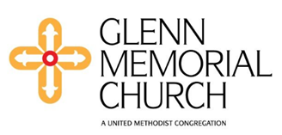

Glenn Memorial Church
1660 North Decatur Road NE, Atlanta, GA 30307
on the Emory University Campus
404-634-3936
glennumc.org

